**MEASUREMENT OF THE READINESS COMPONENT OF GAINTM – A SUMMARY**

The Readiness Axis seeks to measure the ability of a country’s private and public sectors to absorb additional investment resources and apply them effectively towards increasing resiliency to climate change. This focus is similar in spirit to the World Bank’s Country Policy and Institutional Assessment (CPIA) measurements, which determine development assistance for low income countries. The assistance is based on performance in implementing policies that promote economic growth and poverty reduction.

The readiness concept targets those portions of the economy, governance and society that affect the speed and efficiency of absorption and implementation. It attempts to capture for each of these three components how well the prevailing environment facilitates adjustment to change.

For example, if the private sector can easily and quickly set up new businesses, access new capital, refocus as conditions change and obtain resources from other countries, that private sector will be more ready than one with big or lengthy hurdles to business creation, to getting new credit, to expanding, contracting or changing the nature of products, or to moving resources across the border. If resources are brought into a country with rampant bribery and a weak rule of law, chances are good that they will be less efficiently used than in a country where none are skimmed off the top and agreements are dependable. If residents can readily plan how to organize the new resources and collaborate with people in other parts of the country or world, the outcome will be better than where people have little experience organizing, do not understand the potential of the resources and have no way to consult with others elsewhere on implementation.

Readiness also represents aspects of adaptive capacity that can be influenced relatively quickly. If businesses do not face severe barriers, restrictions or monopolies, they can more easily adjust the new demands on the size, scope or focus of their endeavors. If the rule of law is lax, governments can make changes to enhance reliability. Improving a farmer’s warning of weather emergencies can sometimes be as simple as buying a mobile phone.

Without an objective guide to weights, the logical default is to weight each component equally. GaInTM closely approximates that default with components weights:

**33% -Economic** Readiness

**33% -Governance** Readiness

**28% -Social** Readiness

**5% -Reporting** Readiness (how much of the country’s GaInTM data is actually reported versus relying on interpolations – an “expert opinion” based measure).

SELECTING THE CANDIDATES

Unlike for the vulnerability axis, there is a fairly short list of closely applicable candidates for each component. For example, the two chief candidates for the Economy component are The Doing Business Index (World Bank) and The Index of Economic Freedom (The Heritage Foundation/The Wall Street Journal). Each is widely circulated and used. There are also some lesser known indices like the Economic Freedom of the World (Fraser Institute/CATO Foundation).

Candidates for the Governance component include the World Governance Index (World Bank) and the Failed States Index (The Fund for Peace). Moreover, each of the various overall indices has sub-indices that may by themselves add to the measure of readiness.

Choosing among the various indices and subcomponents was based on these criteria:

1. **A minimal set** of indicators should produce a **relevant** score to measure "whether the country will be able to successfully implement adaptation projects"
2. As many (UN) **countries** as possible should be included
3. As many **years** as possible should be included, ideally 1995-2011to be consistent with other important indices. A useful time series allows the construct of readiness changes, enhancing goal of tracking the trajectory within countries
4. Indicators should be as **credible** as possible
5. Data should be as generally **available** as possible (preferably publicly available) so that others could reproduce the results
6. Scores should point to **actionable** **improvements**

Table 1 illustrates part of the process. That table provides the correlations (R-squares) among the overall and sub-indices of the Failed States Index (FSI), the World Governance Index (WGI), the Doing Business Index (DBI) and the Index of Economic Freedom (IEF), plus national measures of the number of professional scientific articles[1] and the number of mobile phones per 100 people[2]. Each variable uses the most recent data available.

Immediately it is clear that information contained in one indicator was often captured by others. The Failed States Index for instance turns out to be very similar in their definitions and correlations to components of the World Governance Indicators (correlations up to 0.6-0.8) and components of the Index of Economic Freedom (0.5-0.8).

**TABLE 1**

**Correlations Among Potential Readiness Indices and Their Subcomponents**

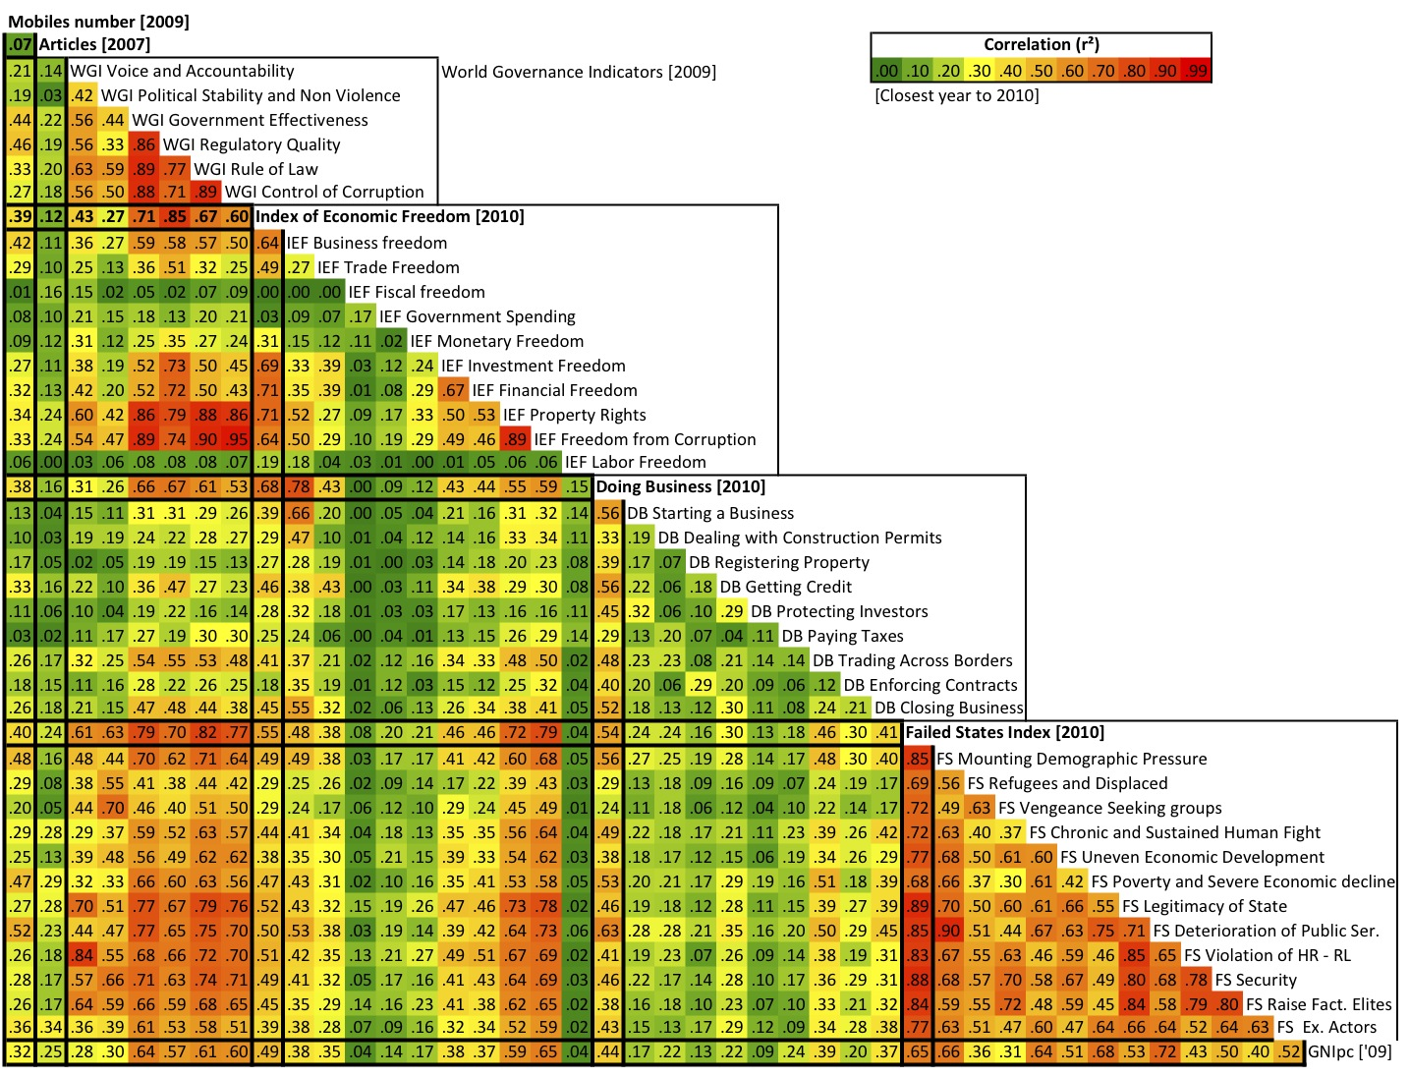

Some of the **Doing Business** Components are not strongly correlated with other candidates, but the overall index is correlated with at least three components of the World Governance Index. It is also highly correlated with the overall IEF (0.7) and its Business Freedom component (.08). These high correlations are not surprising. DB consists of many measures of ease of business as well as some approximating rule of law. An additional drawback of DB is only two years of overall scores (though there are raw scores for each of its subcomponents back to 1995).

Limitations for the **World Governance Indicators** are also immediately apparent. Four of the six components are highly correlated with each other (as high as 0.92).  Clearly there is overlap of information in these components. Moreover the IEF captures most of the information of these 4 components of WGI.  The source of the high correlation is not surprising in half the cases. The Regulatory Quality and Rule of Law components of WGI explicitly use the IEF as a data source (1 of 8 sources for RQ and roughly 1 of 14 sources for RL).

Therefore it does not make sense to include all six WGI components, only the two exceptions ("Voice and Accountability" plus "Political Stability and Non-Violence") that are significantly correlated neither to other WGI components nor to the overall IEF.  These two can add to the overall information.

The **Index of Economic Freedom** closely follows the six criteria listed above. It is one of the most complete in the number of years and countries and is readily available (both for data and methodology). It spans not only the economy component (employing some parts of Doing Business such as number of days to start a business), but also much of the government component such as rule of law and corruption. No wonder that correlations with the IEF seem to capture much of what other variables target. It is also directly actionable. A country with a low readiness score might find that it could improve its score by making it easier to start a business, by reducing corruption or increasing the independence of judges, or allowing a freer flow of capital from the domestic or foreign financial markets.

In contrast to problems encountered elsewhere, the society indicators (number of scholarly articles and number of mobile phones per 100 people) are not significantly correlated to any of the other variables considered.

After various combinations of the variables and finding dead ends, the final GaInTM version 1.0 of the Readiness Axis is captured with the combination consistent with Table X results – Five variables: The IEF, two components from WGI (Voice and Accountability and Political Stability and Non Violence) and the two society indicators. Subsequent versions may consider additional potential variables. Their relevance, however, will be determined in the same manner.

*Weighting the Five Variables and Creating the Readiness Axis*

The Readiness Axis is created through a relative simple process. The values of each of the five variables are normalized between 0 and 1 by dividing each country’s number in the series by the maximum value found among the countries. The scores are then appropriately weighted and then aggregated. Rankings are based on the aggregate score.

As previously noted the weightings are divided among the three components of readiness (economy, governance, society) as follows:

33% -Economic Readiness

33% -Governance Readiness

28% -Social Readiness

5% -Reporting Readiness (how much data in the model is reported by the country versus how much had to be interpolated.).

The Index of Economic Freedom is the only variable in Economic Readiness, so it receives one third of the weight on the Readiness Axis. In contrast Governance has two variables, the Voice and Accountability and Political Stability and Non Violence from the World Governance Index. These are equally weighted, or in other words each receives one sixth of the weight on the Readiness Axis. The two variables in Society, the number of scholarly articles and the number of mobile phones per 100 people, are also equally weighted, receiving 14 percent of the total weight.

Mobiles and Articles have one additional step. It is assumed that once the number of mobile phones per 100 reaches a certain level, the country is saturated. In other words, while an additional phone per 100 may add to the readiness when the number is say 25, at some point enough phones exist that another makes little impact. Clearly where there are 150 phones per 100 people, raising the number to 151 adds little to preparation. It is assumed that the point of saturation is 90 (though it may well be below that level). All countries where the number of phones is 90 or above receive the maximum standardized value of 1.

A similar cap is applied to the number of technical articles. The median for all countries is 153000 (scientific and engineering articles published in the following fields: physics, biology, chemistry, mathematics, clinical medicine, biomedical research, engineering and technology, and earth and space sciences). Once a country produces more than one standard deviation above this median, that country is thought to reach the maximum level of scientific expertise, and the score for that country is again capped at 1.

*Addressing Some Expressed Concerns About the Index of Economic Freedom*

One-third of the overall Readiness score is the IEF alone.

Since we first introduced the use of the IEF, some have expressed concerns that it is too biased. In particular there were concerns that the scores reflect more an advocacy than objective findings. The IEF is produced by The Heritage Foundation whose mission is “promoting conservative public policies based on the principles of free enterprise, limited government, individual freedom, traditional American values, and a strong national defense" and the Wall Street Journal.

We take such feedback seriously. Naturally, the non-partisan Global Adaptation Institute does not support any political bias, and the last thing desired is for people to dismiss what has be done based on the impression that such a bias exists.

We are all constrained by available data. There are only a few established indices that measure the economic environment. The fact that the IEF and the World Bank’s DBI have a strong (0.7) correlation indicates that these indices are arriving at roughly the same conclusions, and that one does not seem to have a political bias more than the other.

The truth is that ***every*** index reflects some bias, because constructing an index requires subjective decisions about what to include. There is no widely accepted, objective way to make this decision.  The IEF reflects the simple question that If you were to identify a free, open, efficient economy, what are the characteristics that you would look for.  Is that a question the Heritage Foundation would ask?  Absolutely.  Is that a question that many economists would ask?  Absolutely.  It therefore reflects not so much the bias of Heritage as the basis of classical economics.  One of the main objectives of the IEF is to define a set of criteria that “developing” countries can use as a guide to how they can improve the quality of life for their residents and allow the residents to use their own personal abilities to the fullest.  Is that a goal reflected in only one political belief?  Don’t we all want a better life for people around the world? The IEF has demonstrated in the past that there is a statistically significant, positive relationship between Changes in a country’s IEF score and changes in growth. A country that increases its score tends to see an increase in its growth rate.

In sum, the IEF is used not because of the institution producing it, but because it is the best Index in terms of the number of countries, the number of years, the openness of data and the methodology. It includes what others are measuring (both definitions and correlated results), and others rely on it for creating their indices.

There is one other similar index – the World Economic Freedom Index put out by the Fraser Institute in Canada and the Cato Institute.  These are often also described as “conservative” institutions. Hence, the same people who are concerned about a Heritage bias would quite likely have similar feelings about Cato.

Another concern expressed is that the IEF is too American/Anglo-Saxon. Again we are all constrained by data limitations.  Most other indices that fit our criteria could have the same charge leveled against them.  The problem is the absence of an African, Asian or Latin American index that that has sufficient country coverage and years of data. We welcome suggestions of geographically dispersed indices. These could then be compared to those we have used to determine if there is significant additional information.

WHAT THE READINESS AXIS TELLS US

The complete country readiness ranking is found in ANNEX 1. Not surprisingly the rankings are highly correlated to the wealth of the country. Table 2a and 2b illustrate this point for the top 10 and bottom 10 countries on the Readiness Axis. The top-ranked countries are highly developed, and the bottom is dominated by some of the poorest of the poor countries.

**Table 2a**

**Top 10 Countries on Readiness Axis**

|  |  |  |
| --- | --- | --- |
| 1 | Australia | 0.84 |
| 2 | Canada | 0.82 |
| 3 | Germany | 0.81 |
| 4 | United Kingdom | 0.80 |
| 5 | Japan | 0.80 |
| 6 | Netherlands | 0.79 |
| 7 | Switzerland | 0.79 |
| 8 | United States | 0.79 |
| 9 | France | 0.77 |
| 10 | Sweden | 0.76 |

**Table 2b**

**Bottom 10 Countries on Readiness Axis**

|  |  |  |
| --- | --- | --- |
| 164 | Uzbekistan | 0.28 |
| 165 | Nepal | 0.27 |
| 166 | Ethiopia | 0.26 |
| 167 | Chad | 0.26 |
| 168 | Iraq | 0.26 |
| 169 | Central African Republic | 0.25 |
| 170 | Congo, D. R. | 0.24 |
| 171 | Cuba | 0.23 |
| 172 | Eritrea | 0.21 |
| 173 | Zimbabwe | 0.18 |
| 174 | Korea, North | 0.13 |

A scatterplot of the Readiness Scores and the log of Gross National Income per capita (GNIpc) (Figure 1) confirms this relationship. There is a very high correlation (almost 0.7) between rank and level of income per capita. However, the plot also reveals that there are important differences among countries even with similar levels of income. Those countries above the trend line have more readiness than their income levels would indicate. These are the countries that may be attractive to private investors. In contrast the countries below the trend line have less readiness than anticipated and are far less attractive for investment.

**FIGURE 1**

**Readiness Score Versus Income Per Capita**

**ANNEX 1 – The Current Readiness Rankings of Countries**

|  |  |  |
| --- | --- | --- |
| 1 | Australia | 0.84 |
| 2 | Canada | 0.82 |
| 3 | Germany | 0.81 |
| 4 | United Kingdom | 0.80 |
| 5 | Japan | 0.80 |
| 6 | Netherlands | 0.79 |
| 7 | Switzerland | 0.79 |
| 8 | United States | 0.79 |
| 9 | France | 0.77 |
| 10 | Sweden | 0.76 |
| 11 | Korea, South | 0.76 |
| 12 | Spain | 0.76 |
| 13 | Denmark | 0.74 |
| 14 | Finland | 0.74 |
| 15 | Italy | 0.74 |
| 16 | New Zealand | 0.73 |
| 17 | Ireland | 0.72 |
| 18 | Austria | 0.71 |
| 19 | Belgium | 0.71 |
| 20 | Norway | 0.71 |
| 21 | Luxembourg | 0.70 |
| 22 | Singapore | 0.70 |
| 23 | Chile | 0.68 |
| 24 | Czech Republic | 0.68 |
| 25 | Poland | 0.68 |
| 26 | Iceland | 0.67 |
| 27 | Brazil | 0.67 |
| 28 | Portugal | 0.66 |
| 29 | Estonia | 0.66 |
| 30 | Mauritius | 0.65 |
| 31 | Slovakia | 0.65 |
| 32 | Saint Lucia | 0.65 |
| 33 | Hungary | 0.65 |
| 34 | Lithuania | 0.65 |
| 35 | Malta | 0.65 |
| 36 | Uruguay | 0.65 |
| 37 | Barbados | 0.64 |
| 38 | Cyprus | 0.64 |
| 39 | Greece | 0.64 |
| 40 | Slovenia | 0.64 |
| 41 | Turkey | 0.64 |
| 42 | St. Vincent & the Grenadines | 0.63 |
| 43 | Dominica | 0.62 |
| 44 | Botswana | 0.62 |
| 45 | Latvia | 0.62 |
| 46 | South Africa | 0.62 |
| 47 | Croatia | 0.61 |
| 48 | Bulgaria | 0.61 |
| 49 | Israel | 0.61 |
| 50 | Montenegro | 0.60 |
| 51 | Romania | 0.60 |
| 52 | Mexico | 0.60 |
| 53 | Qatar | 0.59 |
| 54 | Panama | 0.58 |
| 55 | El Salvador | 0.58 |
| 56 | Bahrain | 0.58 |
| 57 | Trinidad and Tobago | 0.58 |
| 58 | Cape Verde | 0.57 |
| 59 | Oman | 0.57 |
| 60 | Jamaica | 0.57 |
| 61 | India | 0.57 |
| 62 | Albania | 0.56 |
| 63 | United Arab Emirates | 0.56 |
| 64 | Serbia | 0.56 |
| 65 | Malaysia | 0.56 |
| 66 | Kuwait | 0.56 |
| 67 | Argentina | 0.56 |
| 68 | Macedonia | 0.55 |
| 69 | Costa Rica | 0.55 |
| 70 | Russian Federation | 0.55 |
| 71 | Suriname | 0.54 |
| 72 | Seychelles | 0.54 |
| 73 | Namibia | 0.53 |
| 74 | Dominican Republic | 0.53 |
| 75 | Jordan | 0.53 |
| 76 | China | 0.53 |
| 77 | Kazakhstan | 0.53 |
| 78 | Bosnia and Herzegovina | 0.53 |
| 79 | Mongolia | 0.52 |
| 80 | Armenia | 0.52 |
| 81 | Peru | 0.52 |
| 82 | Micronesia | 0.52 |
| 83 | Guatemala | 0.52 |
| 84 | Georgia | 0.52 |
| 85 | Belize | 0.52 |
| 86 | Colombia | 0.51 |
| 87 | Paraguay | 0.51 |
| 88 | Thailand | 0.51 |
| 89 | Ghana | 0.50 |
| 90 | Ukraine | 0.50 |
| 91 | Tunisia | 0.50 |
| 92 | Gabon | 0.50 |
| 93 | Honduras | 0.50 |
| 94 | Vanuatu | 0.49 |
| 95 | Fiji | 0.49 |
| 96 | Saudi Arabia | 0.49 |
| 97 | Bhutan | 0.49 |
| 98 | Maldives | 0.49 |
| 99 | Morocco | 0.49 |
| 100 | Algeria | 0.47 |
| 101 | Tonga | 0.47 |
| 102 | Gambia | 0.47 |
| 103 | Senegal | 0.46 |
| 104 | Moldova, Republic of | 0.46 |
| 105 | Nicaragua | 0.46 |
| 106 | Philippines | 0.46 |
| 107 | Indonesia | 0.46 |
| 108 | Benin | 0.46 |
| 109 | Ecuador | 0.46 |
| 110 | Zambia | 0.45 |
| 111 | Belarus | 0.45 |
| 112 | Azerbaijan | 0.45 |
| 113 | Mozambique | 0.44 |
| 114 | Sao Tome and Principe | 0.44 |
| 115 | Kyrgyzstan | 0.44 |
| 116 | Tanzania, U. R | 0.43 |
| 117 | Mali | 0.43 |
| 118 | Mauritania | 0.43 |
| 119 | Swaziland | 0.43 |
| 120 | Libyan Arab Jamahiriya | 0.43 |
| 121 | Egypt | 0.43 |
| 122 | Viet Nam | 0.42 |
| 123 | Burkina Faso | 0.42 |
| 124 | Kenya | 0.42 |
| 125 | Sri Lanka | 0.42 |
| 126 | Kiribati | 0.41 |
| 127 | Sierra Leone | 0.41 |
| 128 | Lesotho | 0.41 |
| 129 | Madagascar | 0.41 |
| 130 | Bolivia | 0.41 |
| 131 | Guyana | 0.41 |
| 132 | Tajikistan | 0.41 |
| 133 | Cambodia | 0.40 |
| 134 | Guinea-Bissau | 0.40 |
| 135 | Rwanda | 0.39 |
| 136 | Uganda | 0.39 |
| 137 | Malawi | 0.39 |
| 138 | Lebanon | 0.39 |
| 139 | Venezuela | 0.39 |
| 140 | Cameroon | 0.38 |
| 141 | Angola | 0.38 |
| 142 | Nigeria | 0.37 |
| 143 | Niger | 0.37 |
| 144 | Papua New Guinea | 0.37 |
| 145 | Congo | 0.37 |
| 146 | Equatorial Guinea | 0.37 |
| 147 | Syrian Arab Republic | 0.37 |
| 148 | Djibouti | 0.36 |
| 149 | Liberia | 0.36 |
| 150 | Iran, Islamic Republic of | 0.36 |
| 151 | Solomon Islands | 0.35 |
| 152 | Bangladesh | 0.35 |
| 153 | Togo | 0.35 |
| 154 | Lao | 0.34 |
| 155 | Haiti | 0.34 |
| 156 | Pakistan | 0.34 |
| 157 | Comoros | 0.33 |
| 158 | Côte d'Ivoire | 0.32 |
| 159 | Guinea | 0.32 |
| 160 | Burundi | 0.31 |
| 161 | Yemen | 0.30 |
| 162 | Sudan | 0.30 |
| 163 | Turkmenistan | 0.29 |
| 164 | Uzbekistan | 0.28 |
| 165 | Nepal | 0.27 |
| 166 | Ethiopia | 0.26 |
| 167 | Chad | 0.26 |
| 168 | Iraq | 0.26 |
| 169 | Central African Republic | 0.25 |
| 170 | Congo, D. R. | 0.24 |
| 171 | Cuba | 0.23 |
| 172 | Eritrea | 0.21 |
| 173 | Zimbabwe | 0.18 |
| 174 | Korea, North | 0.13 |

1. Scientific and technical journal articles refer to the number of scientific and engineering articles published in the following fields: physics, biology, chemistry, mathematics, clinical medicine, biomedical research, engineering and technology, and earth and space sciences.
2. Mobile cellular telephone subscriptions are subscriptions to a public mobile telephone service using cellular technology, which provide access to the public switched telephone network. Post-paid and prepaid subscriptions are included.